***“PROJECT REPORT”***

GROUP MEMBERS

1)MUSTAFA HUSSAIN

2)MUHAMMED HASSAM

3)MUHAMMED USMAN KHAN.

We the group members jointly collaborated each and every task of project with help and support of one another. In the project we made a **WEBSITE on SUBLIME**, and an **MS ACCESS** database and. In the last we made an **POWERPOINT** **PRESENTATIO**N on the given topic i.e. HOSPITAL. All the work is done in the sequence, all steps and procedure are tried to be taken in consideration which we are taught during our lectures. We have divided our report in 3 parts.

***WEBSITE***

Before starting our website project we made a layout to what to do in our project i.e. we must use navigation, padding, margin, and all other necessary thing must be in our consideration. Here we use CSS , Html and Bootstrap. Which make our sir fruitful.

Here we will discuss the things necessary to mention in report, we use a navigation bar along with a background color, when clicked on it also placed a link on it so to differentiate from a button. Moreover a div is also used, div is basically a container which we used to specify a certain region in our webpage , all thing are written under body tag so to display it on a webpage. Inline, Internal, External CSS is also used where it was necessary. We tried to give Flavors of all necessary things. Multiple ID’s and CLASSES are also used here. And try to make user friendly Website.

***MS ACCES DATABASE***

IN the Ms access database we first go through all necessary thing which we need to maintain our data. We made a pencil record of desired thing.

In the database we made 2tables one for doctor record and the other for patients .

We also made a query to show a relationship , so to get better view and better idea of data and instructions.

Reports and forums are also made to have better view of data.

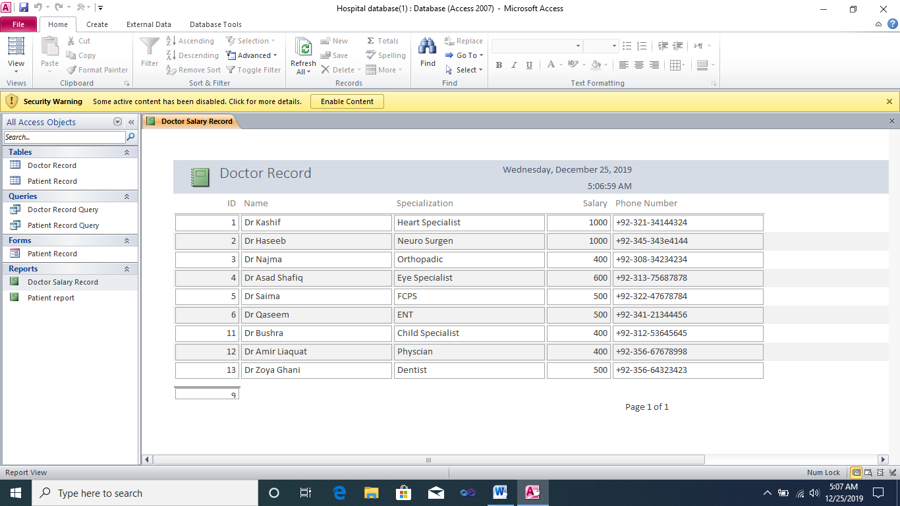

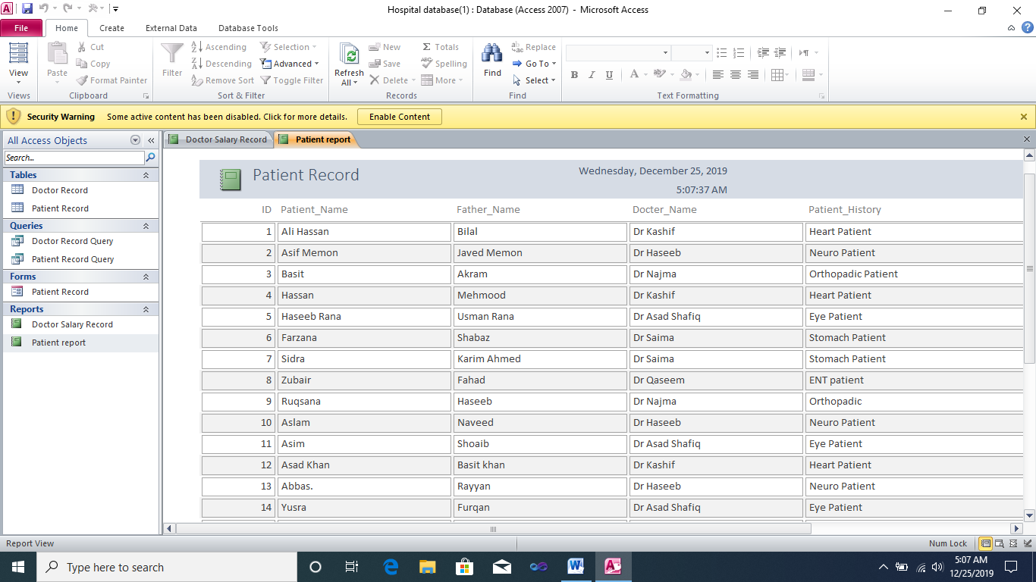

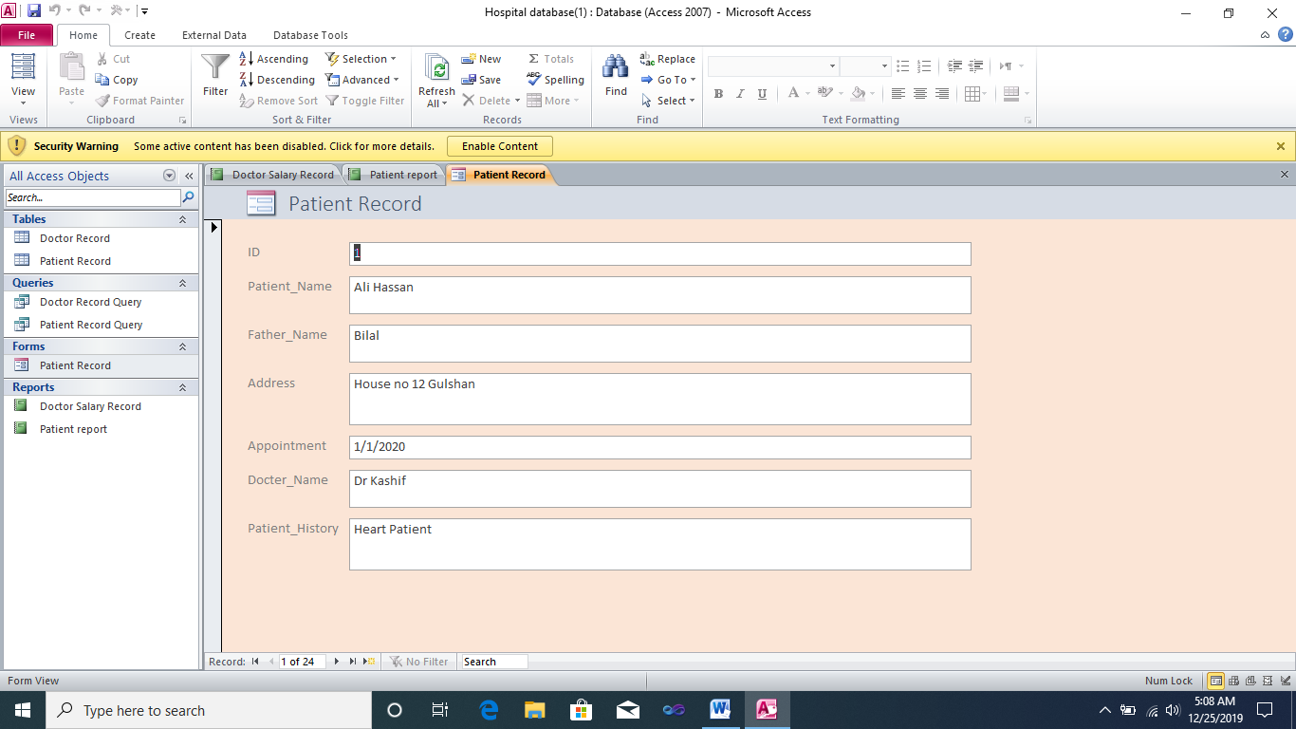

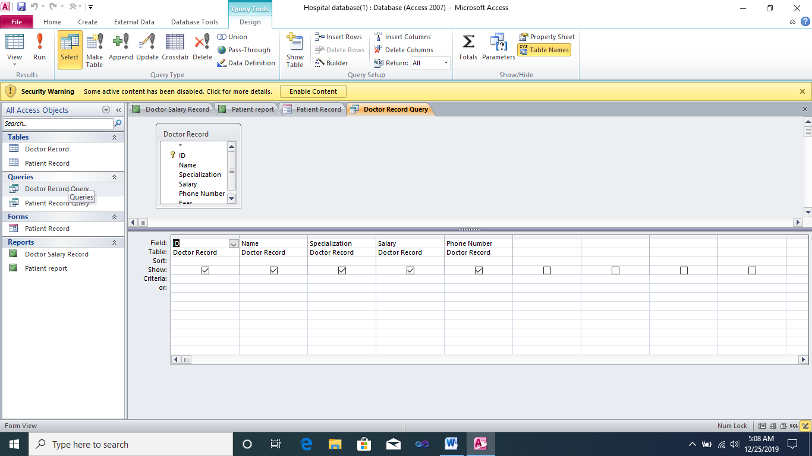

***MS POWERPOINT***

